
Guía de trabajo autónomo para undécimo año (unidad 1)
Self-Study Guide for 11th grade (Unit 1)
El trabajo autónomo es la capacidad de realizar tareas por nosotros mismos, sin necesidad de que nuestros/as docentes estén presentes.
School Name: Liceo Nocturno Juan Santamaría
Student name: Francisco Masis Parrales
Teacher: Flor Brenes Centeno.
Level: 10th
Subject: English

- Me preparo para hacer la guía/ Getting ready to do my self-study guide
Pautas que debo verificar antes de iniciar mi trabajo. /Aspects to verify before I start working:
Materiales o recursos que voy a necesitar/  Materials needed | Suggested materials:  - Notebook, pencil, pen, eraser, highlighters, etc.  - Self- study guide #1 for 11th grade  - Computer & Internet access if possible
Condiciones que debe tener el lugar donde voy a trabajar/ Conditions of the place to work | - Work in a place where you do your assignments and homework daily.
Tiempo en que se espera que realice la guía/  Expected time to work this self-study guide | - This self-study guide will take you 80 minutes to be completed.

- Voy a recordar lo aprendido en clase. Recalling what I learned in class.
Indicaciones /  Instructions | Dear student,  The following tasks will help you review and reinforce Unit 1: Types of food, eating habits and behaviors at the table.
Actividad / Activity  Preguntas para reflexionar y responder  Questions to reflect on and answer | Before reading: Ask yourself… What are some common table manners you learned when you were a child? Write them down on your notebook  Ask your parent or any relative at home… When is for you the best time to teach table manners/behaviors at the table?

- Pongo en práctica lo aprendido en clase / Putting into practice what I learned in class.
Indicaciones /  Instructions | While- reading : Go over the text. Then read each incomplete sentence and select the best option to complete it correctly.  When should I try to teach table manners?  Let’s call table manners acceptable behavior at the table. I hope that you are setting a good example from the very beginning. This means no arguments at the table and staying seated for the entire meal. It also means no television when you are eating.  Don’t complain about the food, don’t share with your child the list of foods you don’t like and why. In other words, your dinner (and lunch and breakfast) table behavior should be pleasant, upbeat, and positive, and considerate of others at the table. Whether you put your elbows on the table and how you hold your fork are issues that you can fine-tune later on. When your child is beginning to eat in a highchair, do not tolerate intentional spills and food throwing. As soon as it happens, stop the meal and get him down, even if he hasn’t eaten very much. The behavior will stop promptly, or at a minimum you will quickly learn that he isn’t hungry. Adapted from www.babycenter.com  1. Table manners means ______________ during mealtimes.  a. getting the child down from the highchair  b. complaining about the food  c. a pleasant atmosphere  2. We should ___________ when having lunch.  a. be seated for the whole meal  b. share our food with others  c. tune a good TV program  3. It is advisable to _____________ at mealtimes.  a. be very hungry  b. argue at times  c.be positive  After- reading  Imagine you have to send a WhatsApp message to your sister because she asked you to help her with some important table manners for her little daughter, your niece. Text her five good table manners for little children.
Indicaciones o preguntas para auto regularse y evaluarse/ Instructions or questions for self-regulation and self- assessment | Review the following questions to self-regulate and self-assess:  Did I read the instructions carefully?  Did I underline the words that I didn’t understand?  Did I use a dictionary or asked a relative about the meaning of the words that I didn’t understand?  Did I read the instructions again when I didn’t understand what I had to do?
PRACTICE
- Guest should be ----------------------at a dinner.
( )Impolite ( )Rude
( )Aggressive ( ) Nice
- Guest should´nt ____________ on the table.
( ) Eat moderately ( ) Be polite
( ) Have a good behavior ( ) Take the first share of food
- If you dislike the dish _______________in the restaurant.
( )Overact ( ) Raise your voice
( ) Tell the waiter nicely ( )Be rude
- Never ----------------------on the table.
( ) Have gum in your mouth ( )Keep a smile on your face
( ) Turn off the cell phone ( ) Suggest new conversations
- It is inappropriate __________________on the table.
( ) Answer the phone ( ) Dress accordingly
( ) To have something new to talk ( ) Be polite

PRACTICE
Respond the following questions in a POSITIVE or NEGATIVE form
Do you eat healthy food ?______________________________
Are you an unhealthy eater ?____________________________
Do you prepare your own meal ?_________________________
Are you a polite guest ?_________________________________
Do you ever have a brunch ?_____________________________

PRACTICE
Read the sentences and classify the following actions Write GOOD or BAD on the line
_________Put your elbows on the table when you are eating
_________Don’t shovel your food into your mouth. Take your time
_________Cut more than three pieces of food at the same time
_________Use a fork to eat your soup
_________Clean your mouth with a napkin

PRACTICE
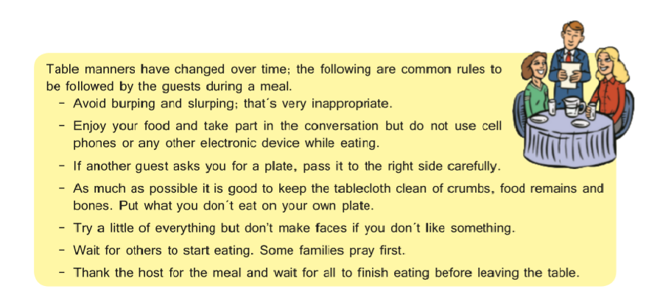
Read the fallowing text about “Common Table Manners” and choose the correct option

- The text says that is socially correct to____________.
( ) burp and slurp ( ) eat the food remains
( ) talk during the meal ( ) finish you food slow

- It is consider rude to _____________.
( ) put food on you plate ( ) wait until everyone is sit to start eating
( ) eating and drinking silently ( ) not to try all the food served

- During the meal it is suggested that you ____________.
( ) ask the guests about the food ( ) answer a phone call during the meal
( ) pass the food dishes to right ( ) say “I don´t like it” when the food is offered

- Guests must ________________ after they have finished the meal.
( ) pray ( ) make faces
( ) thank the hosts ( ) pass the bones

PRACTICE
Write good eating habits and bad eating habits in the following chart.
GOOD EATING HABITS | BAD EATING HABITS

PRACTICE
Write a fast food recipe include the name of the recipe, ingredients that you need and the steps of preparation. Then write all the utensils that you need to cook.

_____________________________________________________

_______________________________________________________________________________________________________________________________________________________________________________________________________________________________________________________________________________________________________________________________________________________________________________________________________________________________________________________________________________________________________________________________________________________________________________________________________________________________________________________________________________________________________________________________________________________________________________________________________________________________________________________________________________________________________________________________________________________________________________________________________________________________________________________________________________________________________________________.

PRACTICE
Investigate and write what type of food corresponding to each word and write the ingredients of each one.
Food | Kind of food | Ingredients
Colliflower
Hamburgers
Lemonade
Rice and beans

Auto Evaluation

Con el trabajo autónomo voy a aprender a aprender/

With the self-study guide, I’m going to learn how to learn.

Reviso las acciones realizadas durante la construcción del trabajo. /
I check the actions carried out while completing the self-study guide

Marco una X encima de cada símbolo al responder las siguientes preguntas/
Mark with an X on the icon that answers the following questions.

¿Leí las indicaciones con detenimiento?  Did I read the instructions carefully? | 
¿Subrayé las palabras que no conocía?
Did I underline the words that I didn’t understand?
¿Busqué en el diccionario o consulté con un familiar el significado de las palabras que no conocía?
Did I use the dictionary or asked a relative about the meaning of the words that I didn’t understand?
¿Me devolví a leer las indicaciones cuando no comprendí qué hacer?
Did I read the instructions again when I didn’t understand what I had to do?

Con el trabajo autónomo voy a aprender a aprender/

With the self-study guide, I’m going to learn how to learn.

Valoro lo realizado al terminar por completo el trabajo.
I self -assess what I did when I finish the study guide.

Marca una X encima de cada símbolo al responder las siguientes preguntas
Mark with an X on the icon that answers the following questions.

¿Leí mi trabajo para saber si es comprensible lo escrito o realizado?
I proofread what I did in my self-study guide.
¿Revisé mi trabajo para asegurarme si todo lo solicitado fue realizado?
I checked my self-study guide to make sure that everything is complete.
¿Me siento satisfecho con el trabajo que realicé?
I feel satisfied with the work I did.
Explico ¿Cuál fue la parte favorita del trabajo?
What was the favorite part of this work?

¿Qué puedo mejorar, la próxima vez que realice la guía de trabajo autónomo?
What can I improve the next time I work on the self study guide?

Lo que necesito saber para completar la guía y las prácticas.
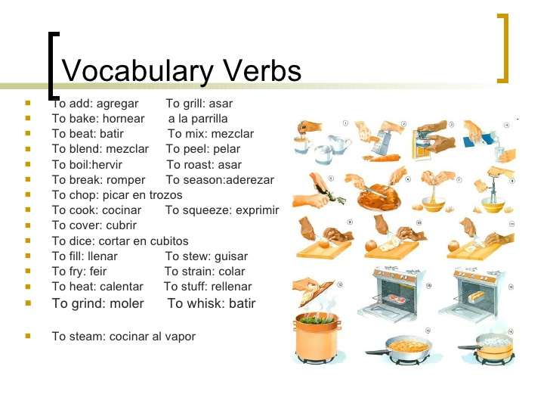
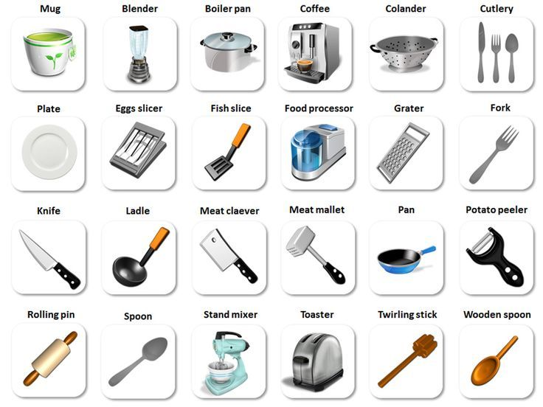
Vocabulario

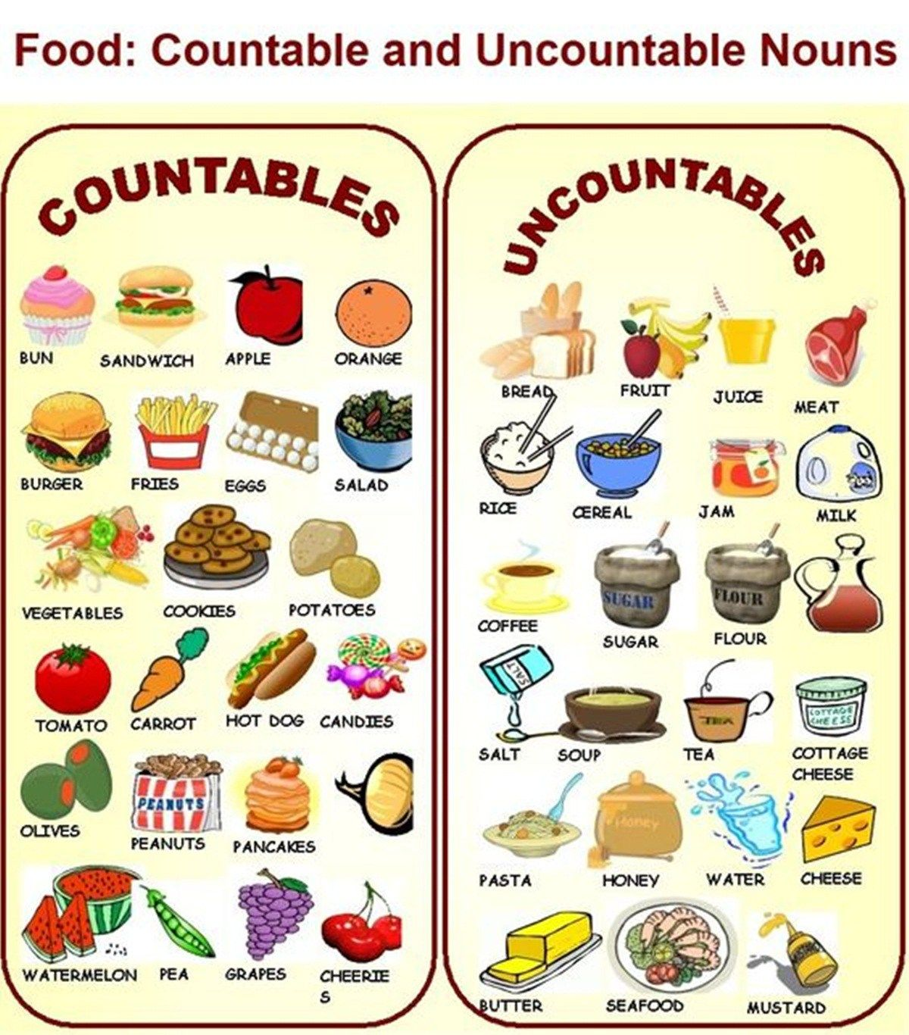

Grammar:
Simple present tense with other verbs.
Subject pronouns
I / First person singular
He
She / Third person singular
It
We
You / First person plural
They

Rules: solo se utilizan en oraciones afirmativas en 3° persona singular
1° : Todos los verbos terminados en “x, s, ss, sh, ch, o, z” se les agrega una “es” al final de verbo por ejemplo:
Dress- Dresses. Fish- Fiches. Fix – fixes
She fixes her car.
Carlos washes his clothes.
2° : Todos los verbos terminados en “Y” pero que antes tengan una vocal se les agrega una “s” por ejemplo: Play- plays. Buy – buys. Stay – stays.
Maria stays at home.
He plays the guitar.
3° : Los vkerbos terminados en “y” pero que antes tengan una consonante se cambia la “Y” por “i” y se agrega “es” por ejemplo:
Study- studies. Fly- Flies. Try- Tries
The plane flies
Pablo studies to hard
4° A todos los demás verbos que no cumplen con las condiciones anteriores se les agrega una “s” por ejemplo:
cook- cooks. Read- reads. Start-starts
she cooks very well.
Ana reads books.
Auxiliares: Los auxiliares solamente se utilizan en preguntas y para oraciones negativas.
Do | Does
I / Yo | She / Ella
You / Tu | He / El
They / Ellos | It / Esto (a)
We / Nosotros
Grammar structure Afirmative form
Subject | verb | Complement.
I | verb | Complement.
You | verb | Complement.
They | verb | Complement.
We | verb | Complement.
Example:
I work at home.
They complete the practice.

Grammar structure Afirmative form with 3° person singular.
Subject | Verb applying rules mentioned above. | Complement.
She | Verb applying rules mentioned above. | Complement.
He | Verb applying rules mentioned above. | Complement.
It | Verb applying rules mentioned above. | Complement.
Example:
He stays at home.
Pedro cooks very well.

Grammar structure Negative form
Subject | Auxiliay | not | verb | complement.
I | do | not | verb | complement.
You
They
We
She | does | not | verb | complement.
He
It
Example: Contractions
I do not like pizza. Do not / Don´t
She does not like hamburgers. Does not / Doesn’t

Grammar structure yes/no questions form
Subject | Subject | verb | Complement?
Do | I | verb | Complement?
Do | you | verb | Complement?
Do | they | verb | Complement?
Do | we | verb | Complement?
Does | she | verb | Complement?
Does | he | verb | Complement?
Does | it | verb | Complement?

Don´t forget to add the question mark.
?

Example:
Do they like pizza?
R/ Yes, they like. / No, they do not. / No, they don’t.
Does he like hamburgers?
R/ Yes, he does. / No, he does not. / No, he doesn´t.

Grammar structure Information questions form
Wh Word or information word | Subject |  | Subject | verb | Complement?
Where | do |  | I | verb | Complement?
When | do |  | you | verb | Complement?
How | do |  | they | verb | Complement?
Why | do |  | we | verb | Complement?
What | does |  | she | verb | Complement?
Which | does |  | he | verb | Complement?
Who…. | does |  | it | verb | Complement?

Don´t forget to add the question mark.
?

Where do they study?
R/They study at home.
When does she worked?
R/ She works at the hospital.
Simple present tense with verb TO BE.
AMAREIS
AM | ARE | IS
I | They | She
 | You | He
 | We | It
Grammar structure Affirmative form
Subject | Verb To be | Complement.
I | Verb To be | Complement.
You | Verb To be | Complement.
They | Verb To be | Complement.
We | Verb To be | Complement.
She
He
It

Grammar structure Negative form
Subject | not | Verb To be | Complement.
I | not | Verb To be | Complement.
You | not | Verb To be | Complement.
They | not | Verb To be | Complement.
We | not | Verb To be | Complement.
She | not | Verb To be | Complement.
He | not | Verb To be | Complement.
It | not | Verb To be | Complement.

Grammar structure Yes or no question form
Subject | Subject | Complement?
Am | I | Complement?
Are | You | Complement?
Are | They | Complement?
Are | We | Complement?
Is | She | Complement?
Is | He | Complement?
Is | It | Complement?

Don´t forget to add the question mark.
?

Grammar structure information question form
Wh. Word or information word | Verb “To be” conjugated | Subject | Complement?
Where | Verb “To be” conjugated | I | Complement?
When | Verb “To be” conjugated | You | Complement?
How | Verb “To be” conjugated | They | Complement?
Why | Verb “To be” conjugated | We | Complement?
What | Verb “To be” conjugated | She | Complement?
Which | Verb “To be” conjugated | He | Complement?
Who…. | Verb “To be” conjugated | It | Complement?
Don´t forget to add the question mark.
?

Examples:
- I am a good student
- It is not a doll.
- Is Marta a nurse?
Yes, she is. / No, she is not. / No, she isn’t
- Where are the students?
Students are at home.
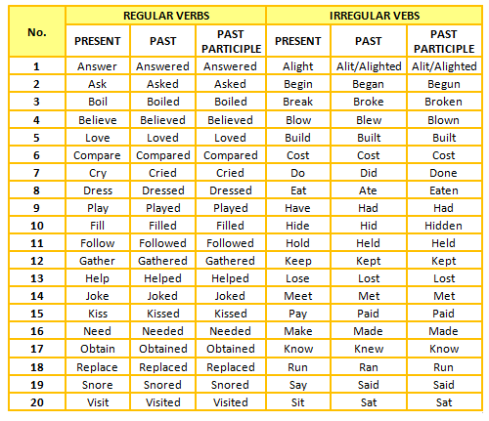
Study this list of verbs

Links de apoyo
https://www.youtube.com/watch?v=BRqCeWKd6p8
https://www.youtube.com/watch?v=gG5w_FWYorM

